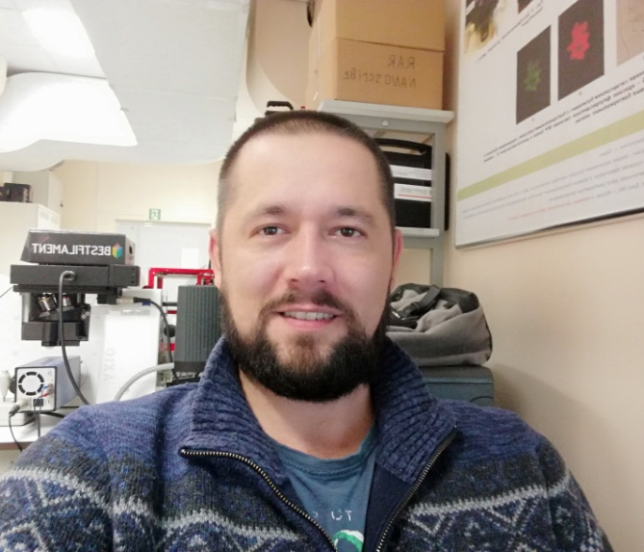
Personal information
Anatolii Otroshchenko
614520 6 Zemlyanichnaya Street, Mokino,
Permskiy kray, Russia
Married
08th Dec 1983
a.otroshchenko@metalab.ifmo.ru,
winzip2014@gmail.com,

Education
Perm State University (Russia), Faculty of Physics, direction: physics (2003-2010)
Research
Microfluidics, Microfluidics device fabrication, Lab_on_a_chip, 3d prototyping, biosenors
EMPLOYMENT
2021 – present. Research Engineer.
ITMO University. St Petersburg, Russia
2012 - 2021 Perm state University. Perm, Russia
I am a Head of the laboratory of Microfluidics at the Department of General Physics. My responsibilities at Physics Department include:
- Setting up equipment and maintaining the performance of laboratory equipment. Only 70 items, the most interesting are: 3d nanoprinter Photonic Professional, plasma processing system Diener Electronic, magnetron sputtering VSM-100, mask aligner system MDA400, developing machine Colenta IL35NG, photoplotter Miva 1624E-T3, 3d microscope Keyence vk-x200, tensiometers Sigma 700 series and other equipment.
- Ensure the functioning of the clean room. (6 class R ISO 14644-1-2000).
- Paperwork related to the purchase and supply of consumables for the laboratory and for the performance of research work.
- Research work consists in fulfilling orders coming to the university from third-party firms, enterprises, laboratories and paramilitary enterprises. In total, from 2015 to 2020, I completed 12 research projects and now carry out two projects. Some of the most significant projects I've done:

______________________________________________________________________
2014-2015 within the framework of the Federal Target Program "Research and Development in Priority Areas of Development of the Scientific and Technological Complex of Russia for 2014 - 2020" (Agreement No. 14.574.21.0028). The theme is "Creation of a biosensor for the detection and monitoring of persistent organic pollutants (polychlorinated biphenyls) in environmental components using bacterial cells and a microfluidic chip." The work was carried out under the guidance of Professor E.G. Plotnikova. The work was patented. In this work, my task was to develop a microfluidic platform and a method for detecting a contaminant.
______________________________________________________________________
Research work on the theme: "Investigation of the morphological features of nanostructured compounds based on transition metal oxides." Customer - INSTITUTE OF SOLID STATE CHEMISTRY (IHTT UB RAS).
______________________________________________________________________
Federal Target Program "Pharma - 2020" State contract No. 14.N08.11.0093, a civil law contract for the performance of research work has been concluded and executed. Development of a system for obtaining monodisperse emulsion “glytifene” based on a microfluidic chip. Conditions, parameters of the system. Development of a production cycle for obtaining a monodisperse emulsion “glytifene”.
______________________________________________________________________
Civil law contract for the implementation of applied and experimental developments. Mission: development of synthesis technology and laboratory regulations for obtaining a pharmaceutical substance, a finished dosage form; carrying out standard control of the developed laboratory regulations; preparation of regulations "Information materials", "Recycling and disposal of waste", "Safety, fire safety and sanitary standards", "Environmental protection". It is a Federal target program "Development of the pharmaceutical and medical industry of the Russian Federation for the period up to 2020 and beyond".
______________________________________________________________________
Research work on measuring fractograms of weld metal fractures in accordance with the requirements (Appendix No. 1). Customer - Federal State Autonomous Institution "Research and Training Center" Welding and Control "at MSTU named after N.E. Bauman "(FGAU" NUTSK at the Bauman Moscow State Technical University)
______________________________________________________________________
Also, I am an assistant at the Department of General Physics. 1/10 of the assistant's rate. Responsibilities include teaching IV year students of the Faculty of Physics practical skills in working with laboratory equipment. I teach students of I-III courses in laboratory studies in mechanics, electricity, molecular physics.
2009-2011 г. Public Joint Stock Company Proton-PM. Perm, Russia
Post - "Production site foreman". This position of the head of the department, our team consisted of 13 employees. I have directed the production of over 1500 different parts for Liquid-Propellant Rocket Engines. The main production task was to manufacture "protection" (it is engine protection elements) for the RD-270 series.
2008-2009 Perm state University. Perm, Russia
Post - Engineer at the Department of General Physics. My responsibilities included setting up and maintaining high technology equipment.
Publications
Several articles co-authored:
- Vaisberg L. A., Baldaeva T. M., Ivanov K. S., Otroshchenko A. A. Screening efficiency with circular and rectilinear vibrations. Obogashchenie Rud. 2016, Vol. 1, pp 3-9
DOI 10.17580/or.2016.01.01
- Baldaeva T. M., Gladkova V. V., Otroshchenko A. A., Ustinov I. D. Mineral coal thermal modification effect upon its vibratory screening efficiency. Obogashchenie Rud. 2017, Vol. 1, pp 3-7
DOI 10.17580/or.2017.01.01
- Baldaeva T. M., Otroshchenko A. A., Vibrating screening of thermally modified coal // Collection of reports at the All-Russian scientific and technical conference of young scientists dedicated to the Year of Ecology "Combined and low-water processes of processing natural and anthropogenic raw materials." St. Petersburg. 2017. pp. 4-14
- OtroshchenkoA.A., MakarikhinI.Yu. Laser 3D lithography, applications (review). Bulletin of Perm University. Physics, 2017, no. 2(36), pp. 9–19. doi: 10.17072/1994-3598-2017-2-9-19
- Gladkova V. V., Kazakov S. V., Karapetyan K. G., Otroshchenko A. A. Vibratory treatment of a particularly brittle mineral material. Obogashchenie Rud. 2018, Vol. 2, pp 8-12
DOI 10.17580/or.2018.02.02
- A.A. Otroshchenko, N.V. Kolchanov, E.A. Kolchanova. Isothermal flow of a magnetic fluid in rectangular microchannels // Reports of the VI Russian conference "Multiphase systems: models, experiment, applications", and schools of young scientists. "Gas hydrates - energy of the future" - Ufa, Russia, Publishing house "Oil and Gas Business", 2017. P. 83

Personal qualities

Reliable, disciplined, energetic, punctual.

References
Dean of the Faculty of Physics at Perm state University
Konstantin Gavrilov
dean.phys@psu.ru

