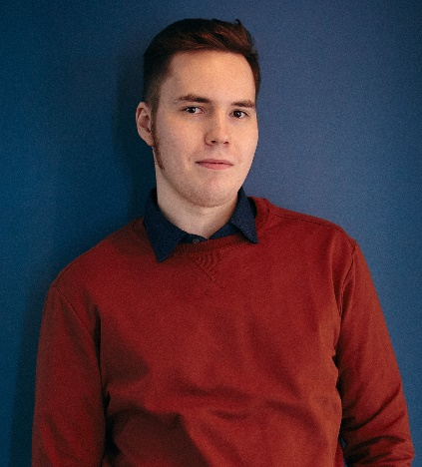
Koromyslov Sergei
Date of birth: 18 July 1998
Mob. phone +79218690079
Email: sergej.koromyslov@metalab.ifmo.ru
Address: Kupchinskaya st. 36, 133, St. Petersburg, 192283, Russian Federation
My research areas include resonant metal-dielectric nanostructures, metasurfaces, femtosecond laser action, broadband photoluminescence, dewetting of thin films, laser printing. This investigation can be useful for developing a new class nanoscale metal-dielectric nanostructure, which would be a source of broadband (white) radiation. I took a part of «Science week SPbPU» conference and winter school «Generation 4.0» based on Peter the Great St. Petersburg Polytechnic University (SPbPU).
Education background
Name of organization: Peter the Great St. Petersburg Polytechnic University (SPbPU)  Contact data: Russian Federation, 195251, St. Petersburg, Polytechnicheskaya 29, international office +7(812) 534-10-02  Website: https://english.spbstu.ru/  Degree of education: Bachelor  Title of direction: 03.03.02 Physics  Title of thesis: «The effect of ultrafast laser induced heating on the indirect-exchange coupling of the RKKY in the Curie switch structures»  Graduation date: 31.08.2020 | September 2016 –  August 2020
Name of organization: ITMO University  Contact data: Russian Federation, 199034, St Petersburg, Birzhevaya line, 16, office 538, phone: +7 (812) 607-02-61  Website: https://en.itmo.ru  Degree of education: Master  Title of direction: 16.04.01Technical physics  Title of thesis: « Laser-induced white light sources based on an ordered array of metal-dielectric (hybrid) nanoparticles» | September 2020 –  Present time

Research experience
Title: Laboratory assistant  Workplace: Ferroic Physics Laboratory (Ioffe Institute)  Contact data: Russian Federation 194021, St Petersburg, Politekhnicheskaya 26, phone: +7(812) 297-22-45  Duties: I participated for creation optical setup, processed and analyzed the results | October 2018 –  June 2020

Title: Research fellow  Workplace: Department of Physics, ITMO University  Contact data: Russian Federation, 199034, St Petersburg, Birzhevaya line, 16, office 538, phone: +7 (812) 607-02-61  Duties: My responsibilities include fabricating particles by dewetting methods, measurements of photoluminescence and Raman scattering, processing and interpreting the data obtained. | September 2020 –  Present time
Oral presentation
- Determination of the value of the indirect-exchange coupling RKKY interaction by the method of magneto-optical polarimetry in the Curie switch structure Fe/(FeCr)/Fe.
S. V. Koromyslov, L. A. Shelukhin, A. M. Kalashnikova, A. F. Kravets
XLII «Week of Science SPbPU» (2019)
List of published and accepted journal papers
- Ponkratova, E., Ageev, E., Komissarenko, F., Koromyslov, S., Kudryashov, D., Mukhin, I., ... & Zuev, D. (2021, April). Femtosecond Laser Fabrication of Hybrid Metal-Dielectric Structures with Nonlinear Photoluminescence. In Photonics (Vol. 8, No. 4, p. 121). Multidisciplinary Digital Publishing Institute.

Additional information
Language: English B1
Computer skills: MS Office, MATLAB, Python, CST, Wolfram Mathematica
Reference
Ageev Eduard, postdoc, Russian Federation, 191002, St. Petersburg, Lomonosov street, 9, «Saturn», tel. mob. +79213821905

